**MINAHIL QADIR**

**BSAI-3A(047)**

**TASK 7:**

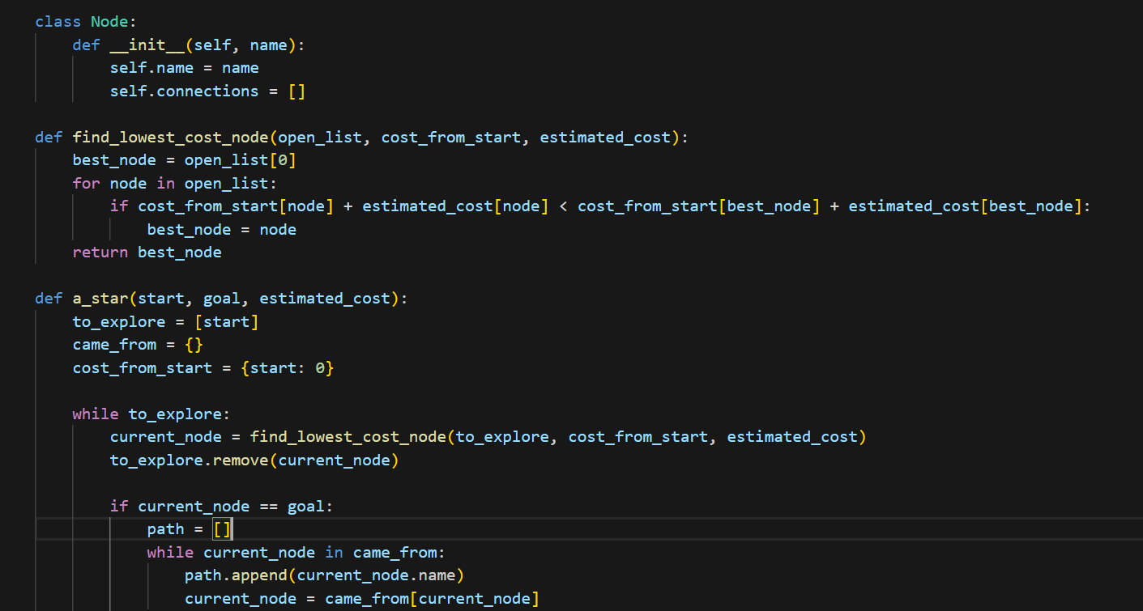 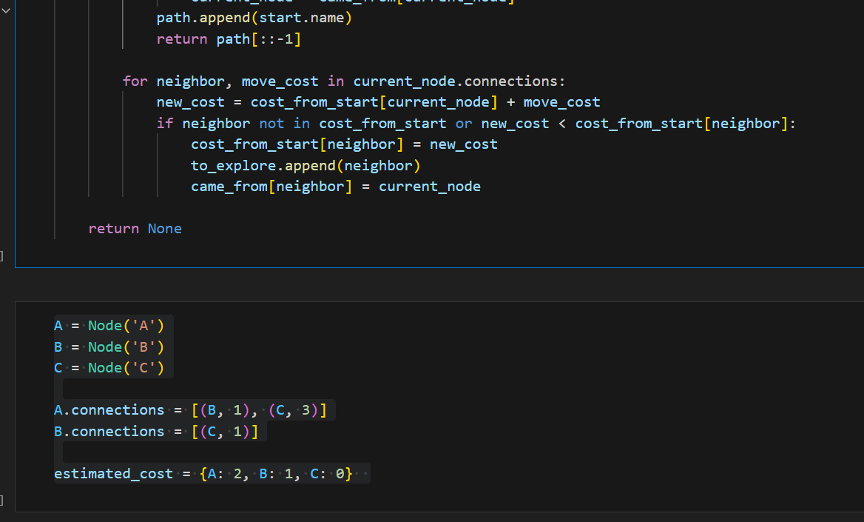

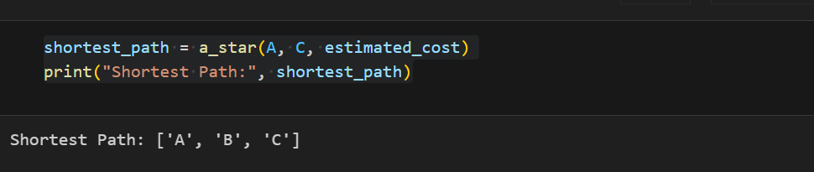

This program finds the shortest path using the *A algorithm*\*.

Each node has a name and connections (paths with costs).

It chooses the best path by adding actual cost + estimated cost.

The algorithm keeps exploring until it reaches the goal.

It traces back the shortest path and prints it.

Example:

A connects to B (cost 1) and C (cost 3).

B connects to C (cost 1).

The algorithm finds the best way from A to C.